**Test Report:**

**Calculator Testing**

**1. Module Name:**

**Calculator Module**

**2. Objective:**

To verify that the calculator application performs accurate mathematical operations, handles valid and invalid inputs correctly, follows standard calculation rules (BODMAS), maintains usability and performance across different scenarios, and provides clear, error-free results to the user under normal and edge case conditions.

**3. Environment Details:**

OS :- Windows 10, Windows 11, Linux, Mac OS, Android

System :- Laptop / Desktop / Smartphone

**4. Test Scenarios Covered:**

1. Verify addition of two numbers
2. Verify subtraction of two numbers
3. Verify multiplication with decimals
4. Verify division result
5. Verify BODMAS
6. Verify percentage calculation
7. Division by zero (Error Handling)
8. Verify repeated equals behaviour
9. Verify long number display

**5. Test Case Results:**

Test case ID :- 1

Test scenario :- Verify addition of two numbers

Test Input :- 5+3

Steps :- Enter 5

Press +

Enter 3

Press =

Status :- Pass

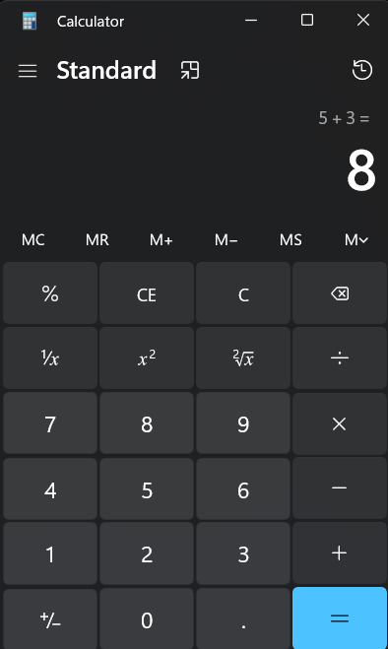

Test case ID :- 2

Test scenario :- Verify subtraction of two numbers

Test Input :- 5 – 3

Steps :- Enter 5

Press -

Enter 3

Press =

Status :- Pass

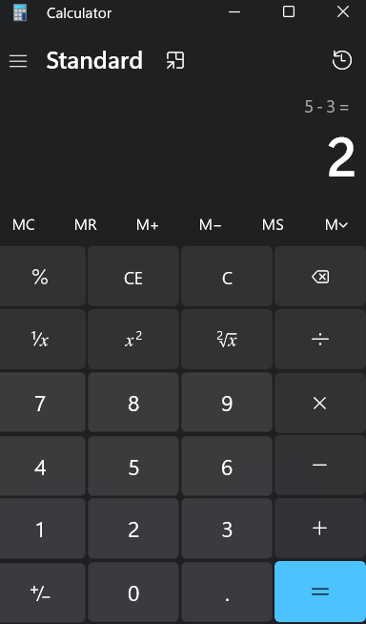

Test case ID :- 3

Test scenario :- Verify multiplication with decimals

Test Input :- 2.5 * 4

Steps :- Enter 2.5

Press *

Enter 4

Press =

Status :- Pass

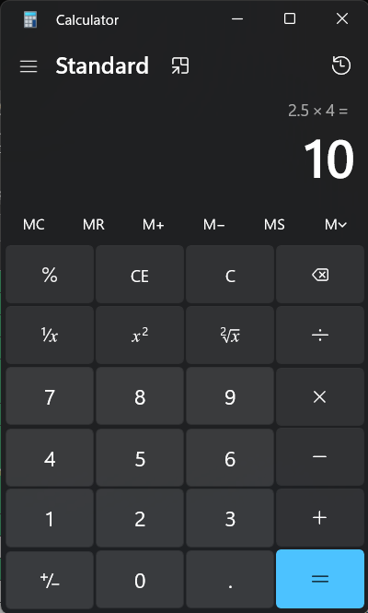

Test case ID :- 4

Test scenario :- Verify division result

Test Input :- 20 / 5

Steps :- Enter 20

Press /

Enter 5

Press =

Status :- Pass

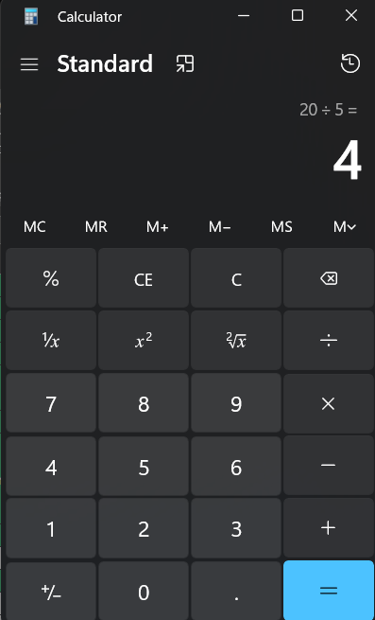

Test case ID :- 5

Test scenario :- Verify BODMAS

Test Input :- 2 + 4 * 5

Steps :- Enter 2

Press +

Enter 4

Press *

Press =

Status :- Fail

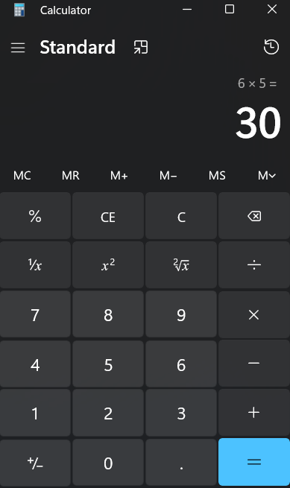

Test case ID :- 6

Test scenario :- Verify percentage calculation

Test Input :- 200 * 10 %

Steps :- Enter 200

Press *

Enter 10

Press %

Status :- Pass

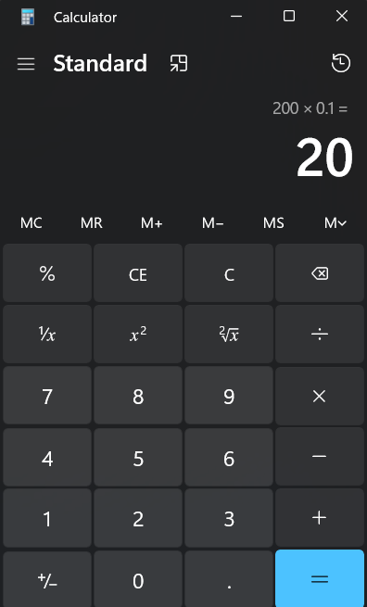

Test case ID :- 7

Test scenario :- Division by zero (Error Handling)

Test Input :- 5 / 0

Steps :- Enter 5

Press /

Enter 0

Press =

Status :- Pass

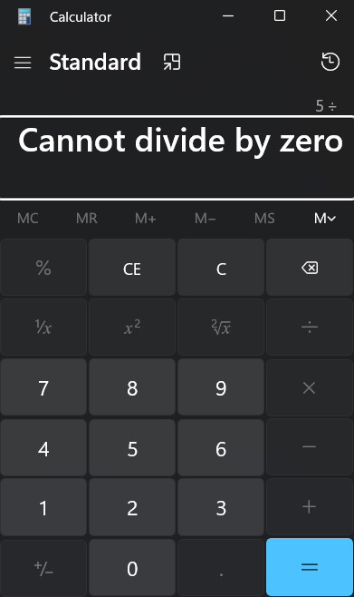

Test case ID :- 8

Test scenario :- Verify repeated equals behaviour

Test Input :- 2 + 2 ===

Steps :- Enter 2

Press +

Enter 2

Press ===

Status :- Pass

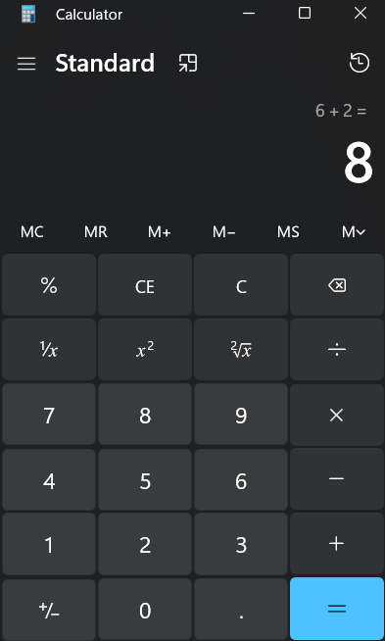

Test case ID :- 9

Test scenario :- Verify long number display

Test Input :- 9999999999 * 9999999999

Steps :- Enter 9999999999

Press *

Enter 9999999999

Press =

Status :- Pass

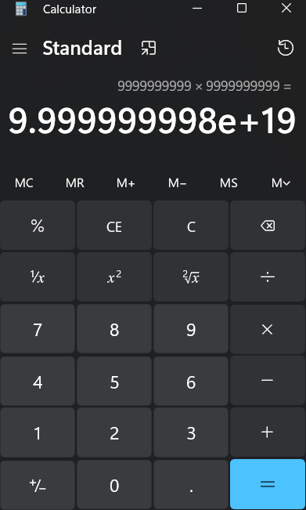

1. **Summery of Test Results :**

Total test :- 9

Passed :- 8

Fails :- 1

1. **Bug Reports :**

**Bug Report 1**

**Bug ID :**- 5  
**Title :- Verify BODMAS**   
**Module :-** Calculator Testing  
**Severity :-** Medium

**Steps to Reproduce :-** Enter 2

Press +

Enter 4

Press *

Press =

**Expected Result :-** Display shows 22  
**Actual Result :-** Display shows 30